Tatevik Azoyan
July 4, 2024

Executive Summary

Search bar functionality in the extension will allow all Haibrid users to quickly find and navigate to any saved web source and Haibrid projects within a selected workspace, saved either by them or shared by their teammates. By reducing additional steps needed to open the webpage, search for projects and then search for sources within projects, it enhances workflow efficiency and saves time, resulting in increased user satisfaction and retention.

Feature Name | Extension Search Bar
Product Area | Extension
User Persona/ Story | All Haibrid users.  As a user, I want to quickly search within all saved sources in a given workspace using the extension only.
Description | Overview  Search bar will allow users to search for sources within a selected workspace, quickly view basic information related to each saved web source, and quickly open the source or project in the main webpage.  Key Features  - Search input in the extension  - Opening saved web pages from the extension  - Navigating to Haibrid projects by clicking on project name
User Problem | - Overwhelming number of web sources.  - Inability to quickly retrieve and navigate across all saved sources.  - Not knowing/remembering the project(s) that a specific source is saved to.  - Having to perform several steps to search for a source using the web app.
Value Proposition | Giving users instant access to all their sources regardless of the page opened, with a single-click on the extension button, and with instant navigation to source pages and project pages in Haibrid, thus reducing friction and cognitive load for users.
Objectives | - Increased Productivity: Reducing cognitive load and improving users’ efficiency  - Increased usability of extension: Boosting extension’s value as one of Haibrid’s unique features and key user activation point.
Assumptions | - Users may want to search for their saved source at random moments of web surfing and would like to have such opportunity without opening Haibrid main webpage  - Users might want to open that web source/a specific project in Haibrid main webpage with the least number of steps possible  - Users may not remember/know which project a specific source was saved to, which makes it very difficult to find a source in the main webpage  - Users may want to quickly view the list of the projects a specific source is saved to and who saved the source
MVP | - Search input in the extension allowing to search across all saved sources within a specified workspace  - Default list of recent searches  - Dynamically changed list of the sources based on search results  - Opening saved source pages and specific project on Haibrid main webpage from the extension
Out of Scope | - Show date added for each source  - Filtering sources saved by the user vs. shared by others  - Highlighting with color the part of the text in the URL/Source name that matches the search input
KPIs | - % of users using the search button among all active users  - Number of times single user uses search input within a week  - Number of Sources opened using the extension search  - Number of times users get redirected to the main Haibrid webpage using the extension search
Requirements | - Need to add an engaging placeholder to indicate which type of search is it  - When clicking on Search button which should be added in the extension/snackbar, a list of recent searches should be displayed, and nothing should be shown if there are no recent searches (dropdown size not exceeding current maximum length of the extension, the number of maximum rows shown will be finalized depending on the design) (TBC)  - Need to dynamically show the list of the sources based on search results if either URL or the source name matches the input, and indicating for each source:  - the URL  - the name as it appears within a project page on Haibrid main website  - the projects that this source is saved to  - the user that saved this source  - Clicking on the URL should open the saved web source on another tab  - Clicking on the project name should open that exact project on Haibrid main web page in another tab (Can open the project page with specific source card expanded - TBC)  - Same sources (URLs) saved to different projects should appear in a separate row each, regardless if the source name is the same or not. 1 location = 1 row (TBC)
Competitor /Market Research | Market Overview  Competitive Analysis  I’ve looked into Notion, Mem, Pocket for inspiration  Market Trends  Competitors’ designs examples for inspiration:  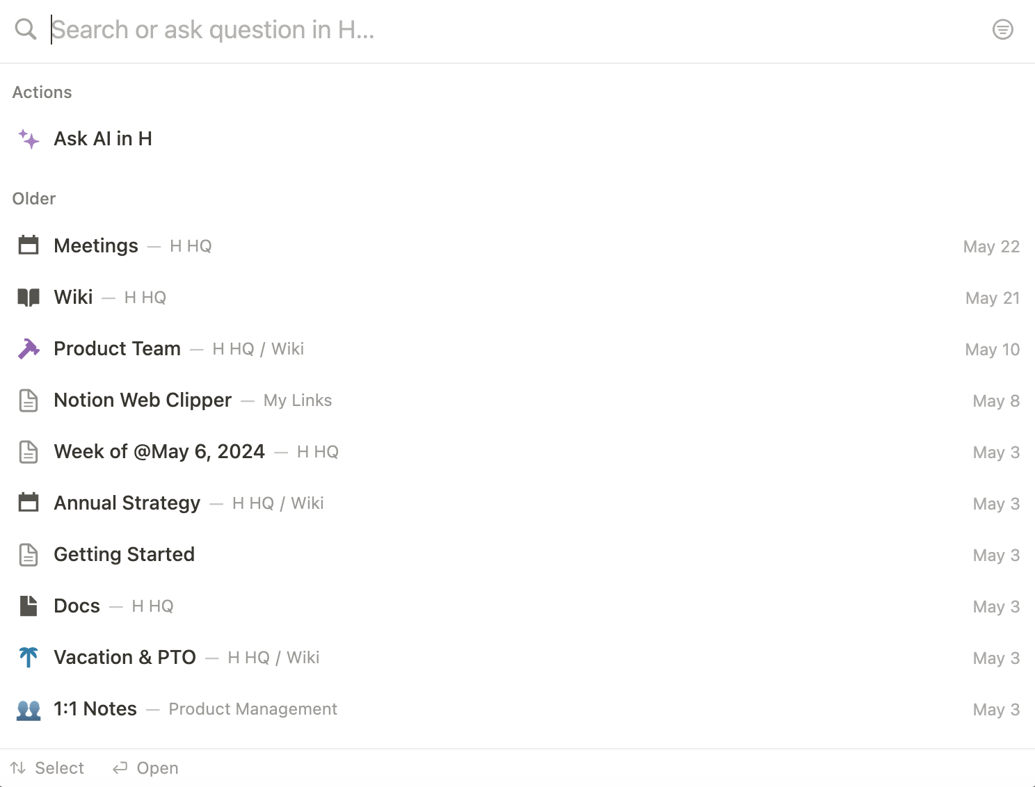  Default view of general search in Notion  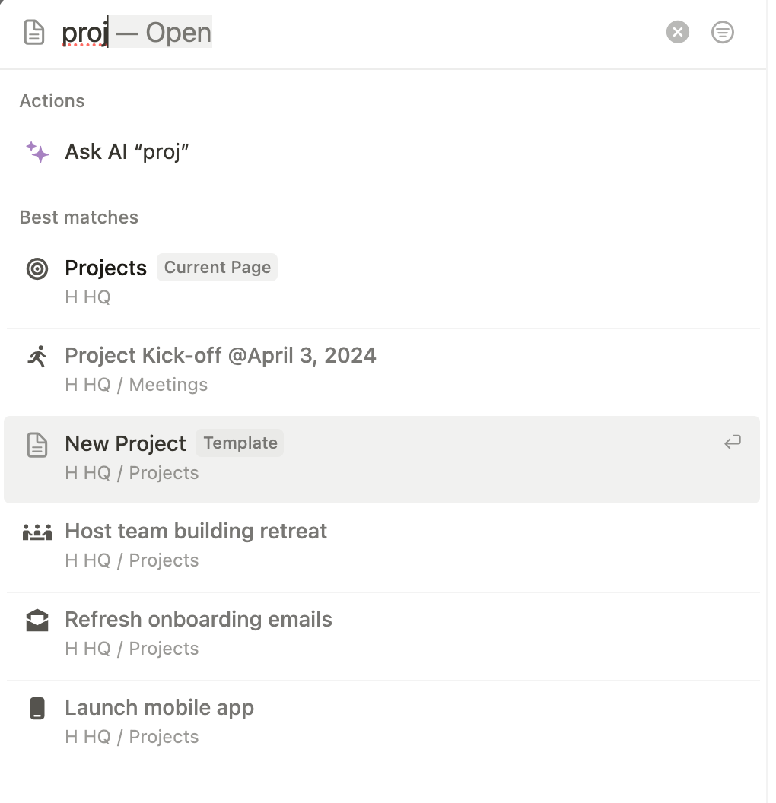  Suggestions based on search results in Notion    Default view of general search in Mem  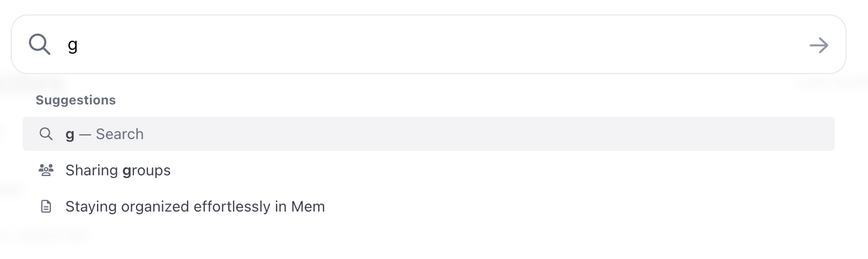  Suggestions based on search results in Mem    Minimalistic general search in Pocket
High-level Mock Ups

